**Policy Video Script**

|  |  |
| --- | --- |
| **Speech** | **Image** |
| To fight climate change and avoid an ever-warming climate, we need an array of policies. Climate policies are needed | Curve of temperature is rising, then an item appears and blocks its further increase, then the curve continue to be drawn but flat. This item is a barred red circle inside of which there is a plane and a car with smoke/pollution. |
| to transform the way we produce energy, to make buildings greener, to put greener cars on the roads and reduce our fuel consumption. But these policies also need to protect people’s jobs and incomes. Let’s have a closer look at three possible climate policies. | Each corresponding item appears when its name is pronounced: a wind turbine below a crane, a barred red circle with polluting car, a person with a gallon of oil in one hand and cash in the other where size of gallon diminishes and cash grows. |
| Let’s start with a policy that forces car producers to produce greener cars – **a** **ban on combustion-engine cars**. | Shows a barred red circle inside of which there is a car with smoke/pollution. |
| With **a** **ban on combustion-engine cars**, first car producers are required to produce cars that emit less CO2 per kilometer. The emission limit is lowered every year, **so** that only electric or hydrogen vehicles **can** be sold after **2030**. Note that electric vehicles **cannot travel as far and** can be more expensive than cars that run on petrol. | Show a car with smoke/pollution next to a factory, then a bill of law with “max 95 gCO2/km [\newline] 2021” written, then the smoke diminishes, then the text becomes “max 60 gCO2/km [\newline] **2025**” and the smoke diminishes further, then “only electric [\newline] **2030**”, the smoke disappears and an electric plug appears on the car |
| Together with a plan to produce electricity from clean sources, **a** **ban on combustion-engine cars** would accomplish the transition needed in the car industry. | The electric car, a sign “+” and wind panels, a sign “=” and a thumb up |
| Now, let’s turn to a policy that combines a tax on carbon emissions to reduce emissions and cash transfers to protect people’s purchasing power. | Shows the person with a gallon of oil in one hand and cash in the other where size of gallon diminishes and cash grows. |
| With a carbon tax, all products that emit greenhouse gases would be taxed. For example, the price of gasoline would increase by 40 cents per gallon**.** | A person fills up her gas tank. The price of gasoline is displayed, and it goes up. |
| With a carbon tax, companies and people pay for the greenhouse gases they emit. This pushes them to reduce their emissions. | The person walk away from her car and takes a bicycle. |
| To compensate people for the price increases, the revenues of the carbon tax would be redistributed to all households, regardless of their income. Each adult would thus receive 600 dollar per year. | Shows a balance with on one side two barrels of oil and on the other side a pile of cash. “+ $300” appears within each barrel so the balance tilts on the barrel side, then new cash comes on the pile with “+$600” above and the balance tilts very slightly towards cash [figures to be adjusted]. Next to the balance is a normal person (e.g. woman in a dress). |
| On average, people with lower incomes own smaller cars, live in smaller houses and fly less, so they use less fossil fuels than the average person. As these people would receive the same cash transfer as everyone else, they will generally benefit from a carbon tax with cash transfers. On the other hand, people with high incomes will tend to lose out. | The person is now a blue collar. Shows the same balance as before with one less barrel: now the balance clearly tilts towards cash. |
| *Does this policy work? Yes! The Canadian province of British Columbia has had a carbon tax with cash transfers in place since 2008. Research has shown that this policy has decreased carbon emissions, increased employment, and made the majority of people financially better off* | *Shows a map of Canada with inside a car with diminishing pollution, 3 blue collars holding cash that turn 4 then 5 blue collars holding more cash (they don’t smile)* |
| The last policy is a large program of public investment in green infrastructure, | Shows a wind turbine below a crane. |
| which would be financed by additional debt taken up by the government. | Shows cash transiting from a bank and the government coffers to the wind turbine/crane. |
| A green infrastructure program would bring about the transition in energy infrastructure needed to halt climate change **but it could come at the expense of other projects**. In the US, **4** **million** people could find a job in green sectors, such as public transport, renewable power plants, buildings’ insulation, or sustainable agriculture, **but 2 million people could lose their job in the fossil fuel industry.** | Show a blue collar next to the wind turbine, then also a person in a bus, then also a construction worker near a building, then also a farmer in a field. **Show a coal miner who loses his helmet and tools.** |
| In general, all climate policies have the potential to transform the economy into a greener, safer, less polluted world. This green transformation has some downsides: people will have to change their habits, and some people will even have to change their job. | Shows a factory / coal power plant, a polluting car and a coal miner, then an arrow, then a wind turbine, a bicycle and a construction worker. |
| For example, there will be less demand for polluting sectors, such as coal mining. But re-training options would be offered to workers in these sectors to make sure that they could find a new job elsewhere. | Shows a coal miner next to the other (but a bit farther away), his helmet switches from mining helmet (with lamp) to construction site helmet and his pick-axe switches to a hammer. (i.e. the coal miner becomes a construction worker) |
| And the green transition also comes with benefits: a safer world for future generations of course, but also less a world with less pollution. And climate policies can be designed to protect those with low and middle incomes households, who can have higher incomes with a carbon tax with cash transfers, and more jobs with a green infrastructure program. | On the right side of the arrow, add several blue collars holding cash. |
| We have focused on three important policies, but many others would also be useful to fight climate change, including funding research into green technologies, subsidising the insulation of buildings, or stopping deforestation. To stop climate change, we probably need all of them together. | Shows a green light bulb, construction to repair a roof, and a growing tree. |

**Climate Video Script**

|  |  |
| --- | --- |
| **Speech** | **Image** |
| Over the past decade, humans have been burning more and more fossil fuels like coal, gas or oil. Burning fossil fuels releases CO2 in the atmosphere. | Graph (if possible, animated) of historic CO2 concentration, next to polluting cars (cars with smoke), planes, and coal power plants / factories (e.g. using <https://www.temperaturerecord.org/> ) |
| Today, the concentration of CO2 in the atmosphere is higher than at any time over the last 800,000 years. | Unzoom to show graph of concentration over 800,000 years |
| Climate scientists agree: it’s the accumulation of greenhouse gases like CO2 released by human activity into the atmosphere that increases temperatures and causes climate change. | Show graph of temperatures (e.g. using <https://www.temperaturerecord.org/> ) |
| A rapid transition away from fossil fuels is technically feasible and could limit the increase in global temperatures to 2°C. | Extends graph of temperatures with 2°C scenario (e.g. using the figure below), and some wind turbines and trees on the side |
| But if greenhouse gas emissions continue on their current trend, global temperatures will rise by 4°C in 2100 and 7°C in 2200. | Keep previous graph but adds a +4°C scenario (e.g. using the figure below), and on the side now there is a polluting car and a coal power plant / factory |
| *This may seem far away, but we can already feel the consequences of climate change with heat waves, droughts and other disasters intensifying. Air pollution caused by the burning of fossil fuels is already responsible for 6 million deaths worldwide each year.* | *Shows a skull with “6,000,000”, then a desert with a shrub drying.* |
| Here are some of the impacts expected by scientists in the absence of ambitious actions to halt climate change: | The thermometer rises between 3 and 4°C (color red) |
| * there would be more frequent and more severe natural disasters, such as hurricanes, heat waves, droughts, floods, and forest fires | A hurricane, a drought, and a fire appear when there names are pronounced |
| * by 2070, one third of the global population could have to migrate toward places where the temperature remains suited for humans | Shows a family with suitcase, leaving there house in the middle of the desert, under a bright sun |
| * by 2100, rising sea levels would flood the land where hundreds of million people currently live | Shows a house near a beach, the sea-level rises (shrinking the size of the beach), then a waves comes and floods the house |
| * agricultural yields would decrease in most regions | Shows a banana tree with bananas on it (or any other crop), and some bananas dry up or disappear |
| * a large proportion of species and ecosystems would face an increased risk of extinction (for example, half of the Amazon rainforest could be replaced by savannah by the end of the century) | Shows a tropical forest (for example a few trees with a bird and a snake) that dries up, the trees lose their leaves, some fall, and the bird also falls dead |
| *On average, each American emits 18 tons of CO2 per year.* | *A person from the US (i.e. a man with the American flag) with a polluting car [or without?], the size of the pollution clouds proportional to the emission, and within the cloud “18t” is written, and next to that the Earth with a pollution cloud (of size corresponding to 4.4t)* |
| *To stop climate change, we need to bring these emissions down to zero in the coming decades. This is possible, but it requires a deep transformation in the sectors most responsible for greenhouse gas emissions: energy, transport, and industry.* | *Shows the second figure below.* |

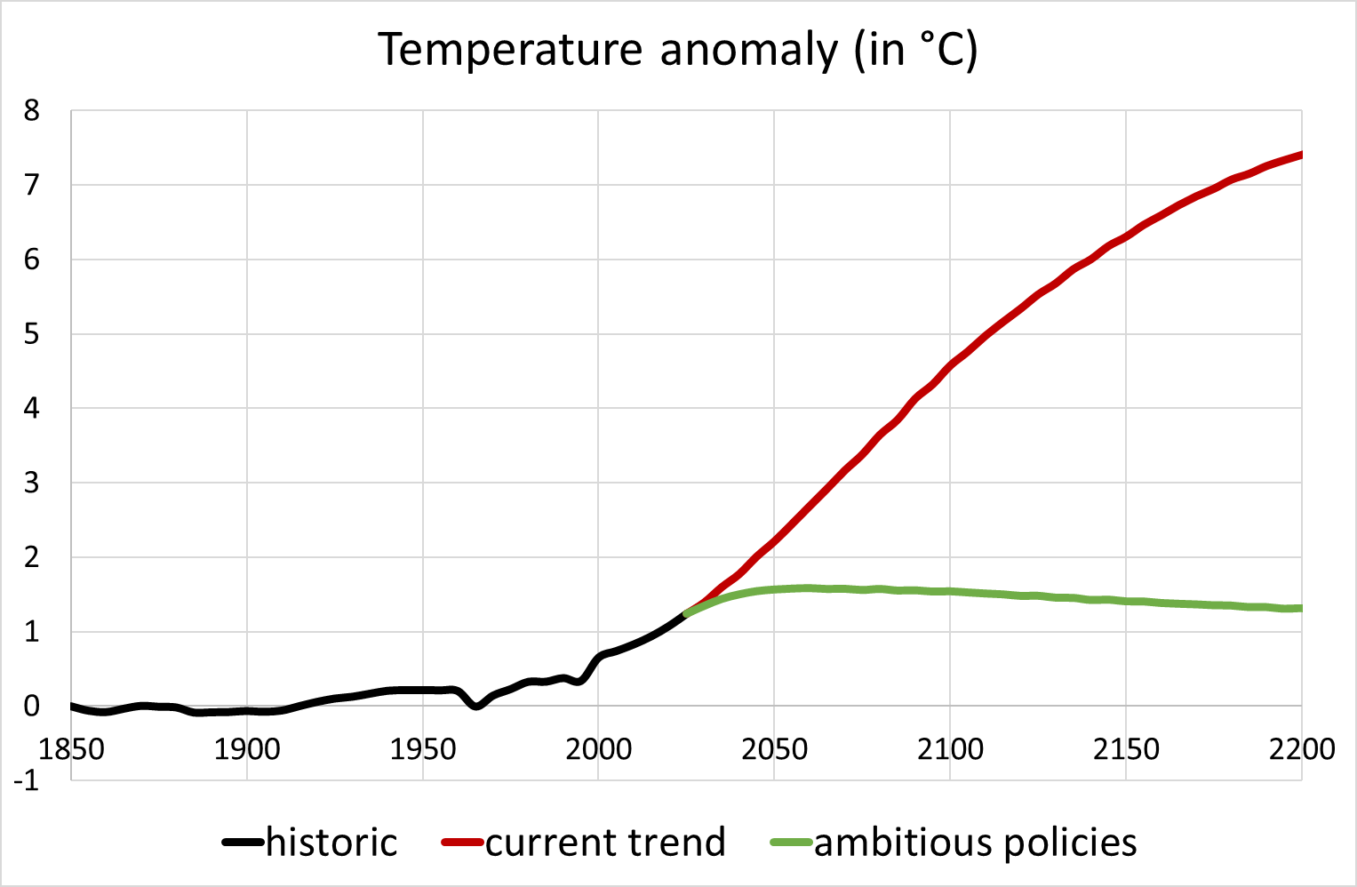

Source: Meinshausen et al. (2011) https://link.springer.com/article/10.1007/s10584-011-0156-z

There is also a version of this graph in French and in °F

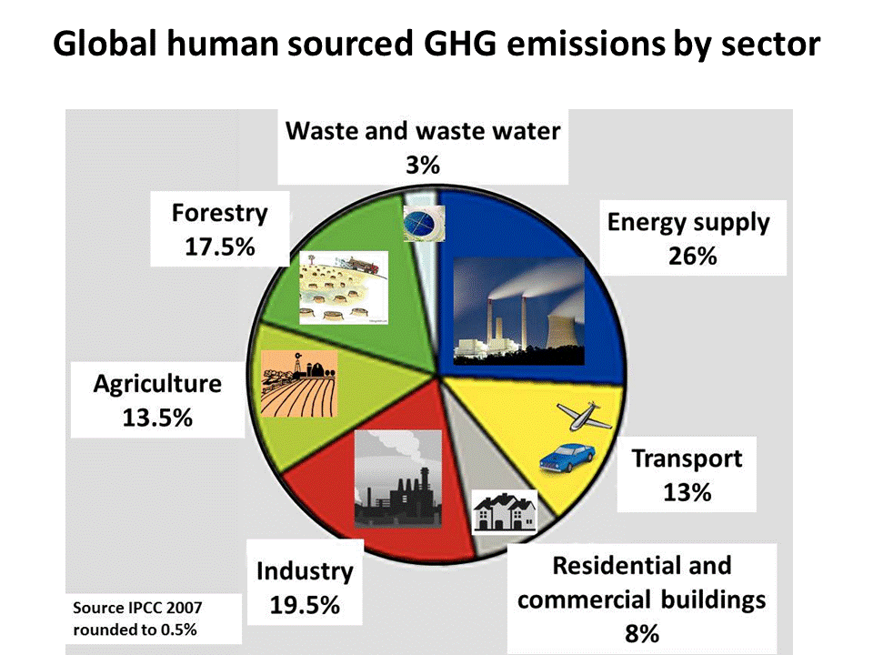

Source: https://i.pinimg.com/originals/28/f0/72/28f07273a64c12a313c3ad49ab8e5bae.gif